|  |
| --- |
| **National University of Computer and Emerging Sciences** |
| Lab Manual 3a  “Creating Master Pages and Using Web Templates” |
|  |
| Database Systems |
| Spring 2018 |

Department of Computer Science

FAST-NU, Lahore, Pakistan

**Table of Contents**

1. Objective 2

2. Task Distribution 2

3. What are Master Pages? 3

4. How to create master page in ASP.net web project 4

5. Using Templates to design Master Page 7

6. Using master page in web forms 11

# Objective

The purpose of this document is to give a practical exercise of creating and using master pages and to use website templates in ASP.net web projects.

# Task Distribution

|  |  |
| --- | --- |
| Total Time | 60 Minutes |
| Introduction | 10 Minutes |
| Demo | 10 Minutes |
| Exercise | 40 Minutes |

# What are Master Pages?

Master pages allow you to create a consistent look and behavior for all the pages (or group of pages) in your web application.

A master page provides a template for other pages, with shared layout and functionality. The master page defines placeholders for the content, which can be overridden by content pages. The output result is a combination of the master page and the content page.

The content pages contain the content you want to display.

When users request the content page, ASP.NET merges the pages to produce output that combines the layout of the master page with the content of the content page.

For more info Visit

<http://www.w3schools.com/aspnet/aspnet_masterpages.asp>

<http://msdn.microsoft.com/en-us/library/wtxbf3hh.ASPX>

# How to create master page in ASP.net web project

The following Exercise will demonstrated how to create and use Master Pages in ASP.net using visual studio.

**Step 1.**

Create a New Project in Visual Studio , Selecting ASP.Net Web Application and .Net Framework 4 in middle Pane and Visual C# Web in left Pane

Name your project MyWebSite (follow figure 1 )

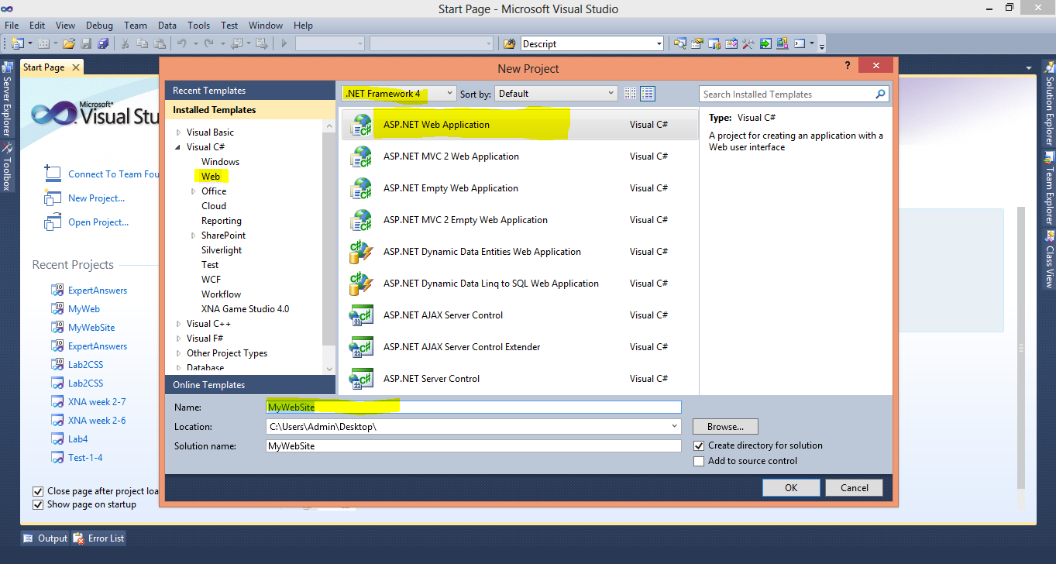

Figure 1 Step 1

**Step 2.**

Add Master Page in your Project, using Add New Item Option from Solution Explorer (Follow Figure 2 and 3)

Name this Master Page as MyMasterPage.Master

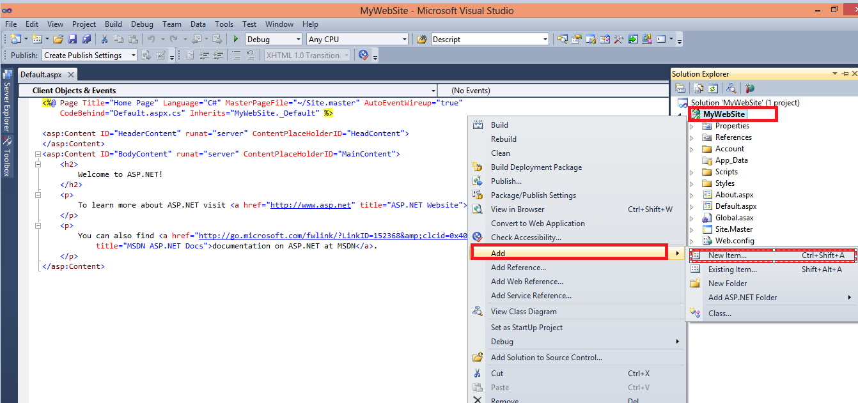

Figure 2

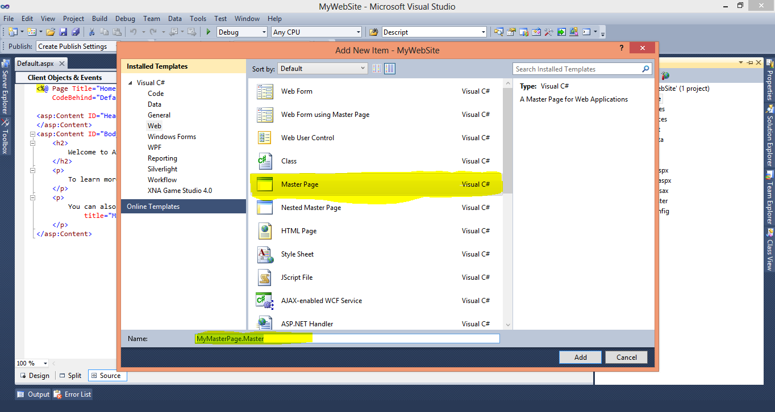

Figure 3

**Step 4.**

Open the Master page you just created and view its Source code and design using Split window option.

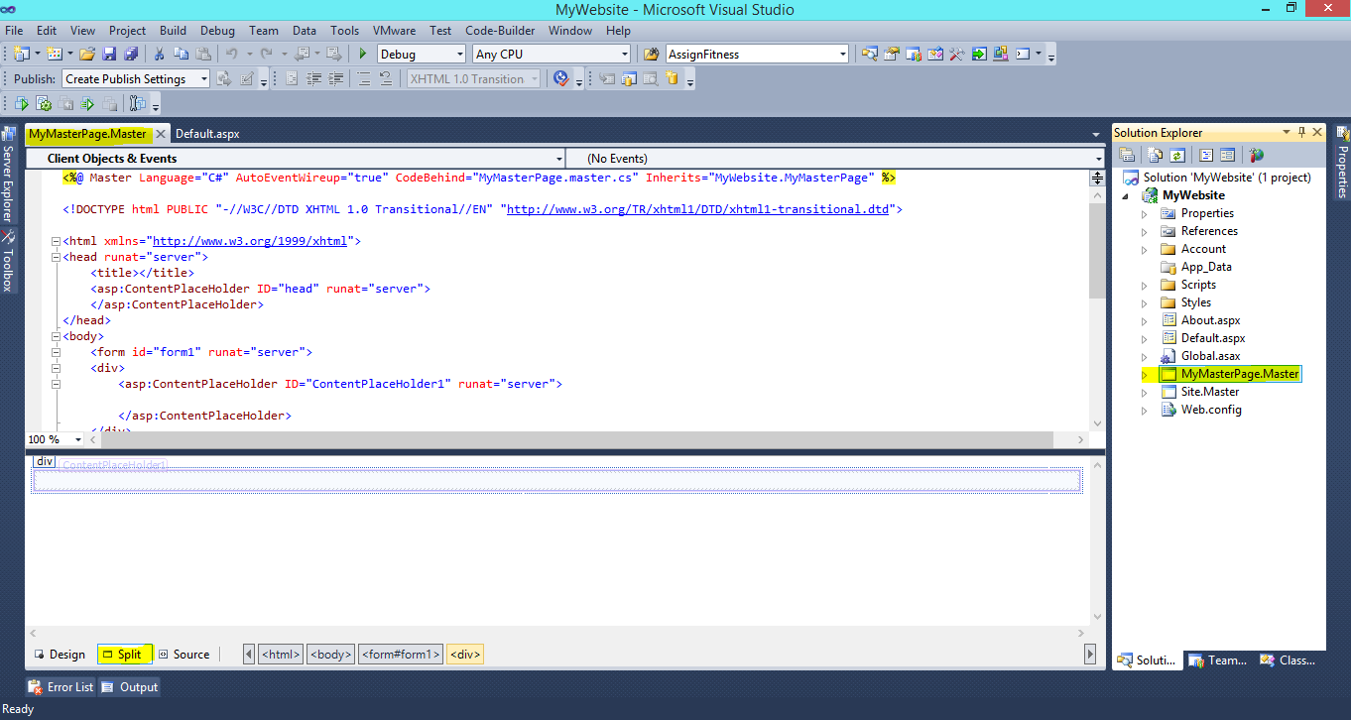

Now modify the code of master page by adding a simple text in it (as shown in figure) are see the changes in Design window

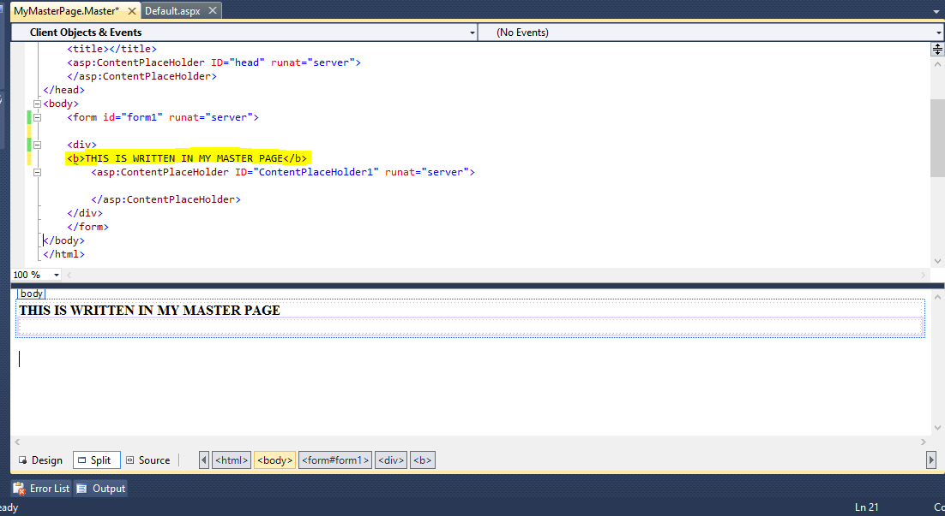

# Using Templates to design Master Page

You can design your own mater page from scratch or you can download some good template and use it in designing the master page. Following Exercise will show you how to use templates in your projects.

* The Web Template is downloaded from
* [*http://all-free-download.com/free-website-templates/*](http://all-free-download.com/free-website-templates/)
* You can also download template from this website for your Projects
* The Template used for This Lab Exercise is
* [*http://all-free-download.com/free-website-templates/snow_glass_215.html*](http://all-free-download.com/free-website-templates/snow_glass_215.html)

The contents of template are given in *lab3/TEMPLATE snow_glass_215* folder, open index.html file in browser. We will design our master page like this.

**Step1.**

Add the CSS file given in template to your project, using Add Existing Item option.

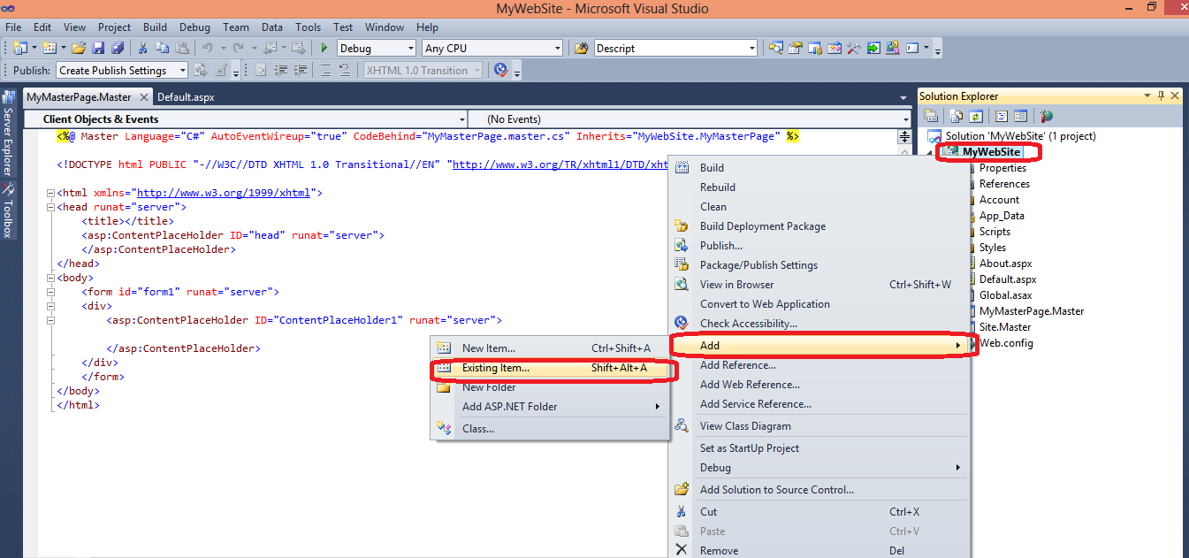

**Step2.**

Create new Folder in your Project named Images using New Folder option (As shown in Figure)

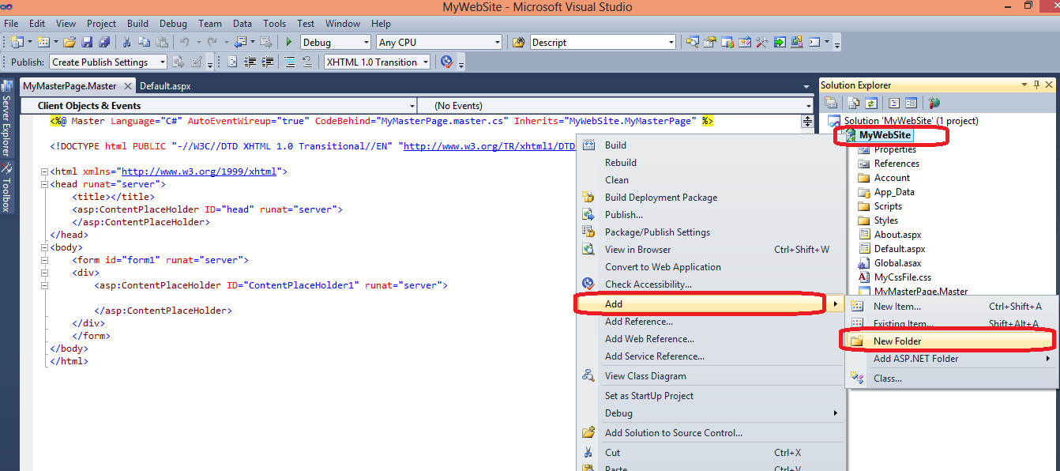

**Step 3**

Now add all the images given in TEMPLATE snow_glass_215\images folder in this Images folder, (as shown in figure)

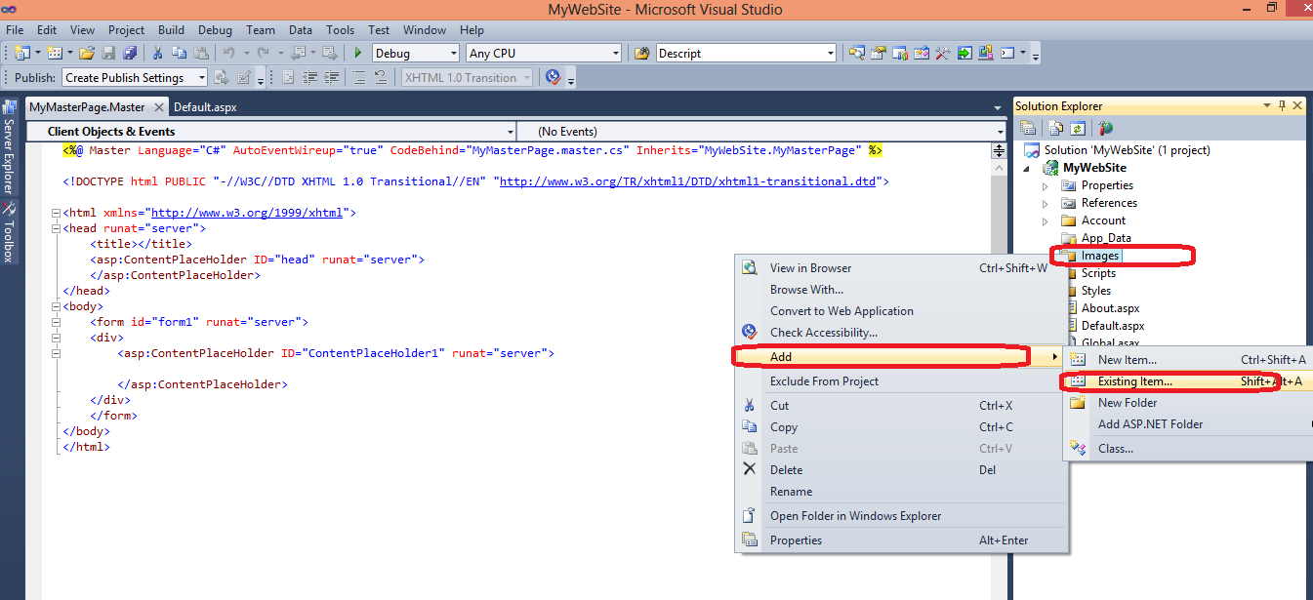

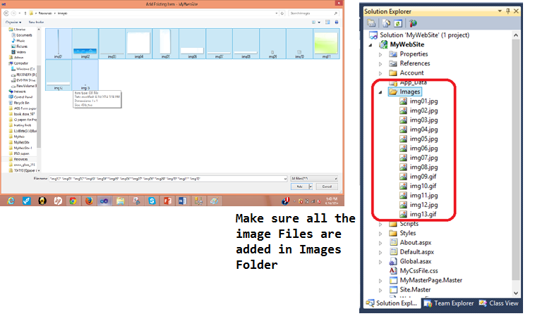

**Step 4.**

Now open MyMasterPage and Drag Drop Css file in Header (as shown in Figure)

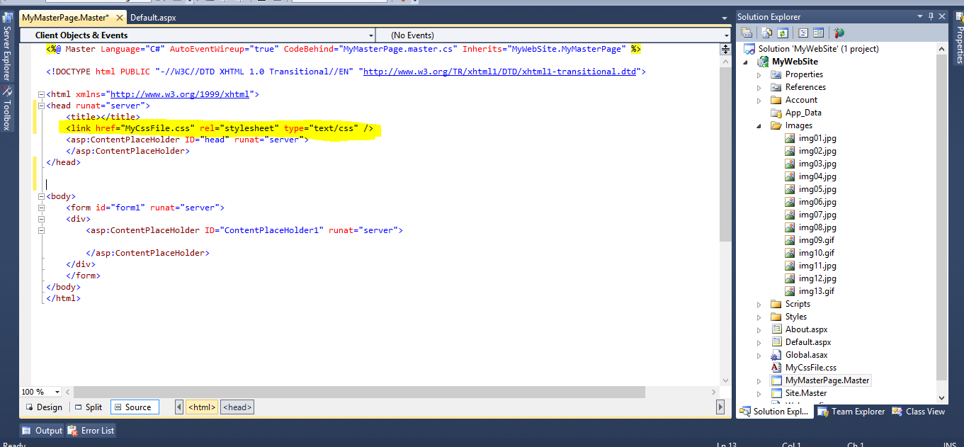

**Step 5.**

Now open the index.html file in Notepad. We are not going to use all these tags in our Master page instead we will just use header and footer <div> in the body of our Master page as shown in figure

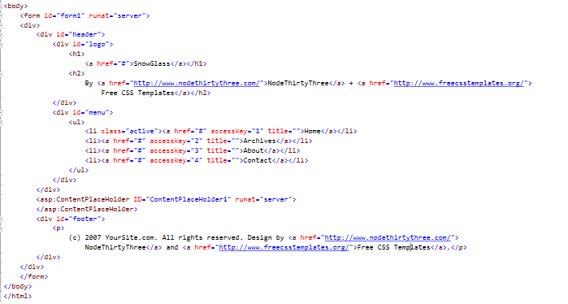

View it in Design Window

# Using master page in web forms

Now you can use this master page in and Web form of your project, following exercise will show how.

**Step 1:**

Add a Web form Using Master Page in your project. Name it Home.aspx

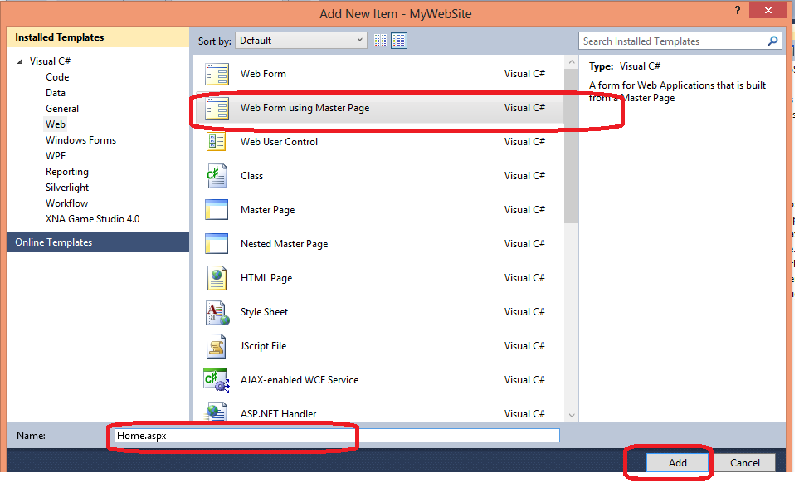

Chose MyMasterPage.Master from Selection Popup

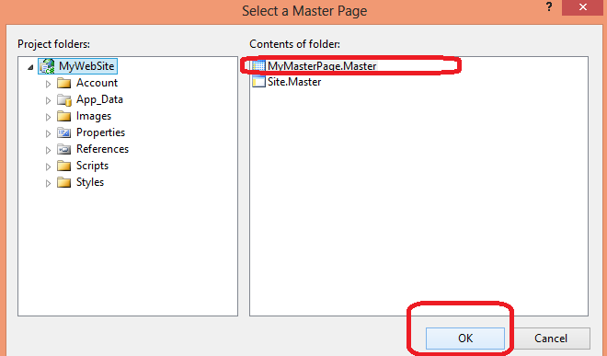

Similarly add another Web Form using Master Page in your Project, Name it **Search.aspx**

**Step 2:**

Add simple text in ContentPlaceHolder1 in your home page. As shown in Figure

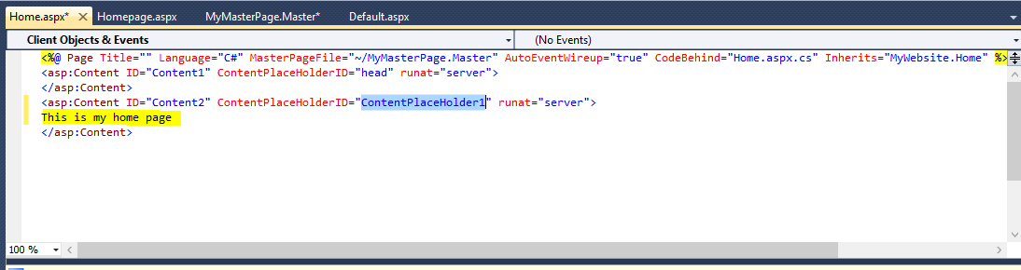

Similarly add some text and text box in Search.aspx page as well as shown in figure.

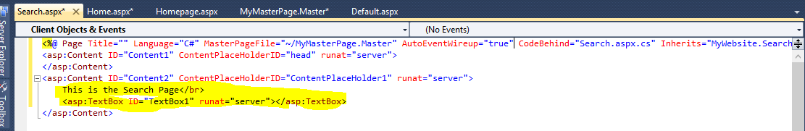

Open you Master page and change the **href** for header bar to home.aspx and search.aspx

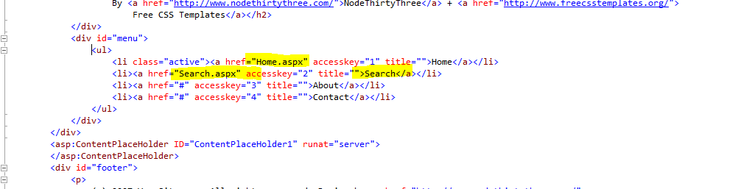

**Step 3.**

**Now run you project**

This is the home page

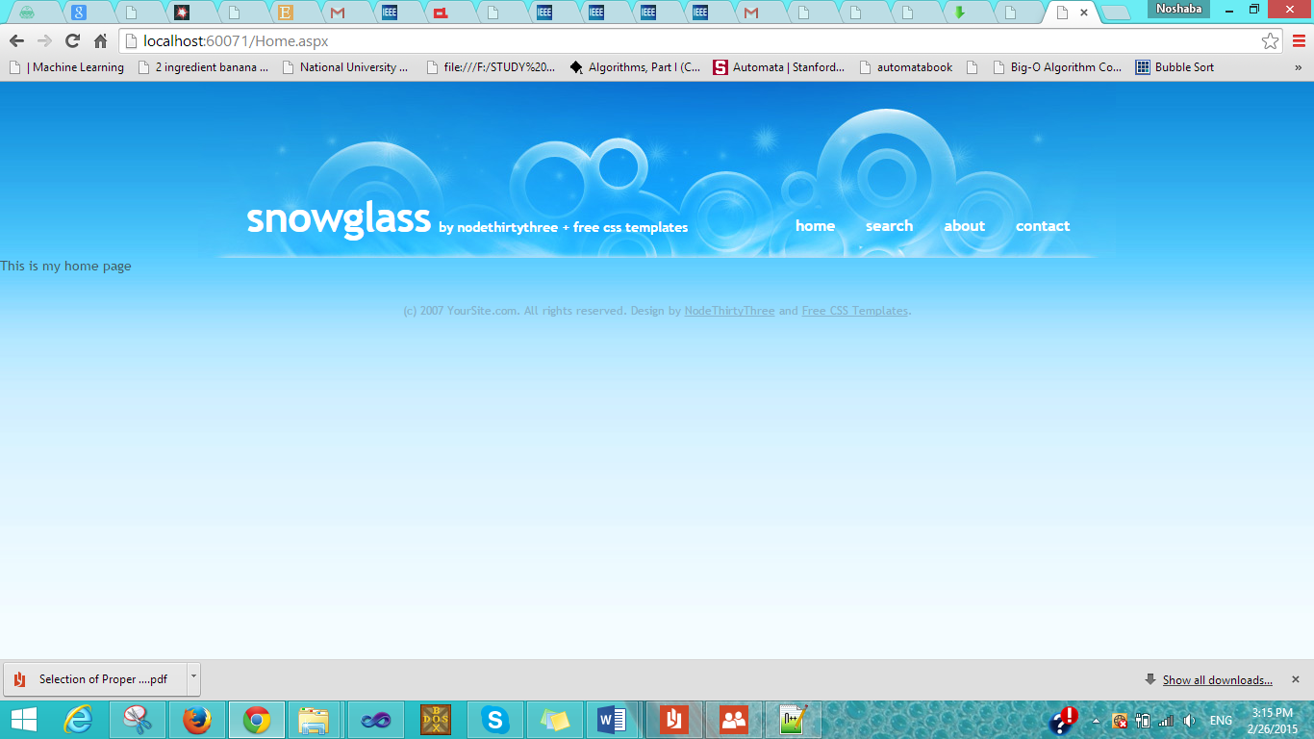

Click on Search link and it will take you to Search.aspx page

